MIAMI SOUTHEAST HISTORIC BUILDINGS

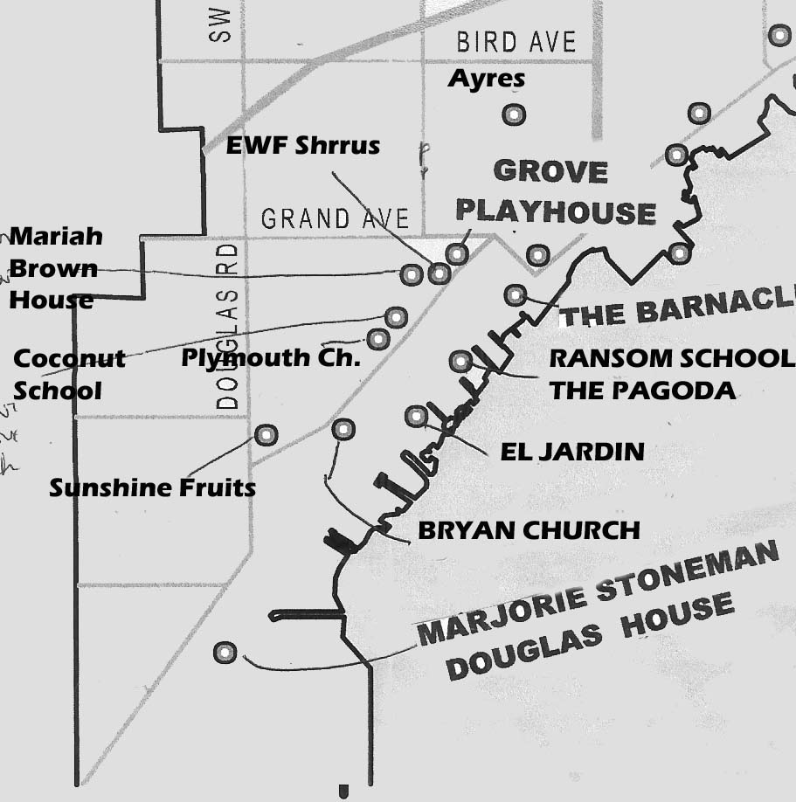
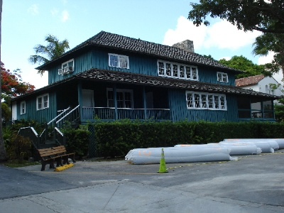 THE PAGODA at Ransom
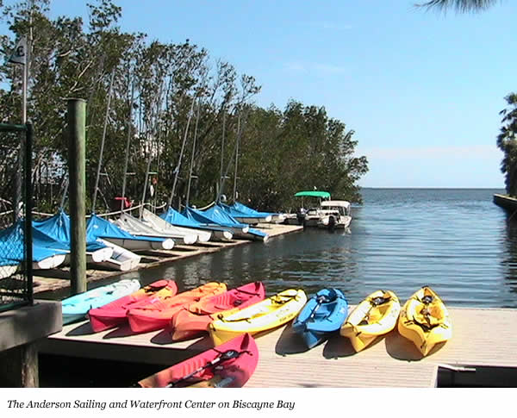
Ransom School (The Pagoda)
3575 Main Highway
Year Built: 1902
Architects: Greene and Wicks
Paul Ransom established the nation's first two-campus migratory boarding school in 1895 and offered a curriculum that would prepare students for college and life. The Pagoda at Ransom-Everglades School is associated with one of Coconut Grove's oldest private schools and is one of the few surviving buildings from the pioneer days of Miami-Dade County. Constructed of local pine, the building has a brick and oolitic limestone chimney, and 39 piers of native oolitic limestone anchor the building to the sloping ridge overlooking Biscayne Bay. The waterfront school has been the site of lots of “rich kids” sites in movies filmed in Miami.

The Coconut Grove Playhouse
3500 Main Highway
Year Built: 1926
Architects: Kiehnel and Elliot (1926), Alfred Browning Parker (1955)
The center of Miami’s theater life for many decades, the Grove was started by Miami entrepreneurs Irving J. Thomas and Fin L. Pierce who planned "The Grove," as a luxurious movie theater for the Paramount Enterprises chain. The theater was designed to resemble a Spanish Rococo palace. Reduced to a second-run theater after World War II, the building was shuttered in 1954 due to increasing competition from television. Rechristened the Coconut Grove Playhouse, the facility reopened as a live theater in 1956. Operating as a non-profit organization, it became a nationally recognized regional theater., but in recent years have faced problems of competing giant shows.
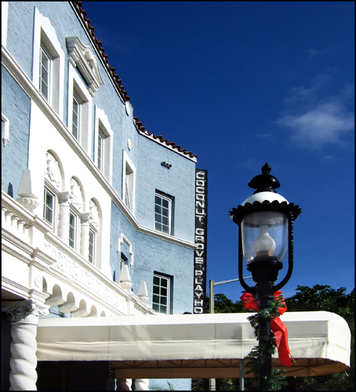
El Jardin
3747 Main Highway
Built in 1918 along a ridge of oolitic limestone, El Jardin expresses the broad training of its architect, Richard Kiehnel, and the experience of its owner, John Bindley, then president of Pittsburgh Steel. Kiehnel, in a September 1928 article for Tropical Home and Garden, referred to the house as a first of the Modern Mediterranean style homes.
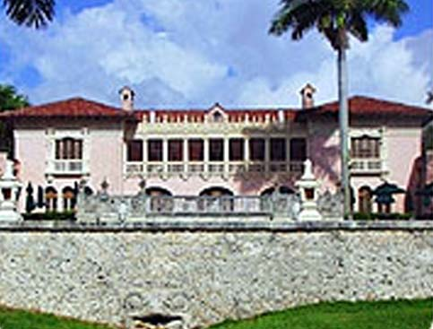
Marjory Stoneman Douglas House
3744-3754 Stewart Avenue
Years Built: 1924-1926
Architect: George Hyde
Dr Carlton Tebeau introduced me to this great author, activist, and fairy godmother of the Everglades in the early 1960’s. I thought she seemed veryu frail, but I was very wrong/ When she died in 1998 at age 108, Douglas was probably best known as an environmentalist. In 1947, she focused national attention on Florida's unique natural resources with her book, The Everglades: River of Grass, which she wrote in this house. This house is like its author – simple and clear in goal featuring an eclectic combination of Tudor Revival and Medieval Revival details.
