LAKE WALES, FLORIDA

LAKE WALES was first surveyed in 1852, but development didn’t really grow until the railroad system began to reach the area by the 1890’s. Developers discovered the possibilities of lumber operations and citrus production on the fertile ridge of Central Florida, Lake Wales was close to the end of the Central Highlands of Florida. Iron Mountain, topped by Bok Tower, is the highest point in peninsular Florida at 289 feet.
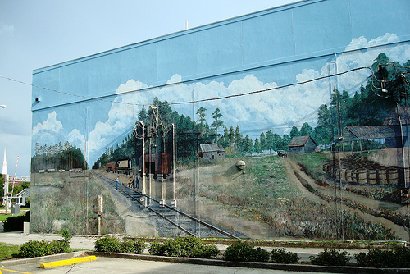
When the Atlantic Coastline Railroad reached Babson Park in 1911, C. V. Tillman, B. K. Bullard, E. C. Stuart, and C. L. Johnson formed the Lake Wales Land Company. Seeking Northern residents they hired engineer A. C. Nydeggar to plat a city that was a gem in small town planning. In 1930 the famous Olmstead brothers landscaped the city of Lake Wales and neighboring Bok Tower with its Mountain Lake resort.
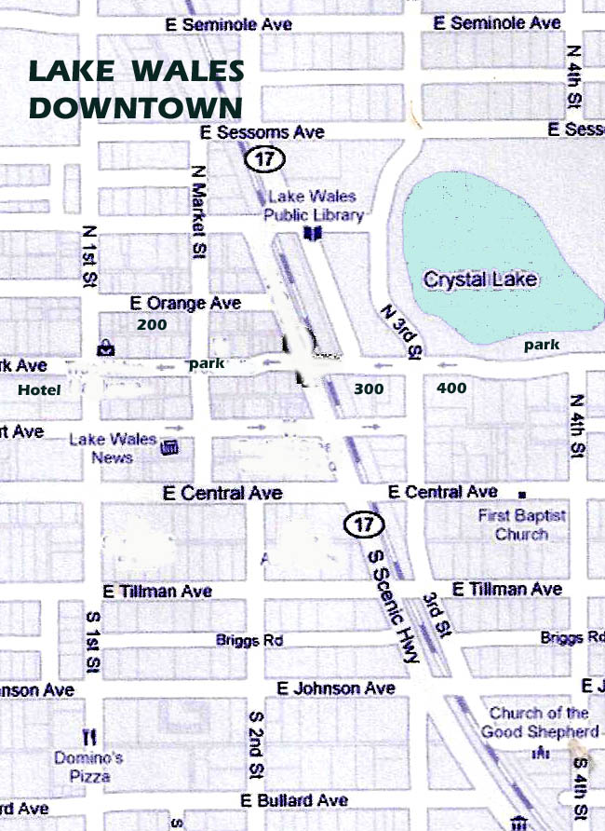
It is appropriate that Park Avenue is Lake Wale’s Main Street started by the ten-story DIXIE-WALESBILT HOTEL (115 North First Street). Built in the Bust year of 1826, the Grand hotel has seen many lives with a retirement residence being the latest.
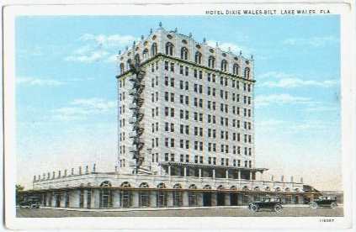
At the start of Park Avenue is the town symbol, the 1921 TOWN CLOCK, which once stood by the railroad tracks to welcome visitor. Now it marks the Town Square.
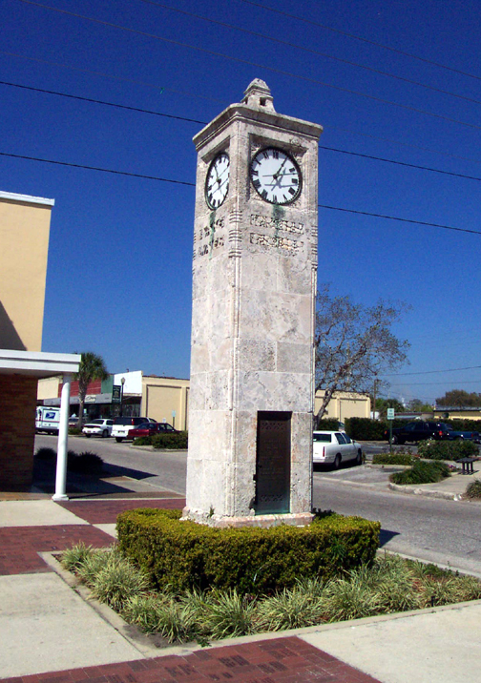
Nearby at 4 West Park Avenue is the UNITED STATES POST OFFICE (1940), a WPA project with the era’s popular Art Deco design.
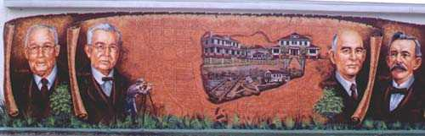
Downtown Lake Wales is compact and small, but that has helped preserve its architectural heritage. At 229 East Park Avenue is the lovely 1924 RODESBILT ARCADE designed by Jesse T. Rhodes in a Mediterranean Revival style. If you think the arched entranceway is going to reveal a gorgeous interior and ceiling, you are correct.
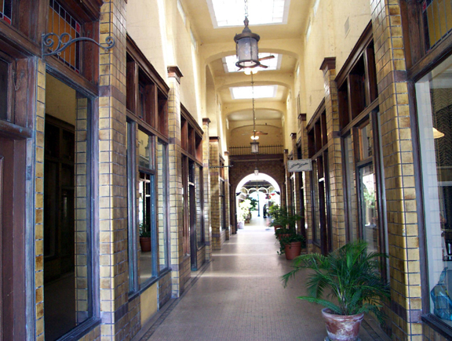
Next door is the two-story 1920 J. Y. RHODES BUILDING (255 East Park Avenue) and the LAKE WALES PHARMACY (245 East Park Avenue) started by pioneer T. J. Parker. Lake Wales hasn’t allowed ugly modern buildings break up the downtown profile.

Across the street was one of the centers of Land Boom activity: the 1919 WESTERN UNION BUILDING (340 East Park Avenue). At 250 East Park Avenue is the 1915 LAKE WALES STATE BANK, a Greek Revival brick structure with powerful Tuscan columns.

On the next commercial street Stuart Avenue are two of Lake Wales most attractive structures: the 1926 two-story GIBSON & LILLY BUILDING with its iron posted Mediterranean style, and the SCENIC THEATER (254 East Stuart Avenue) whose 400-seat capacity in 1920 showed the builders hoped for a high society community.
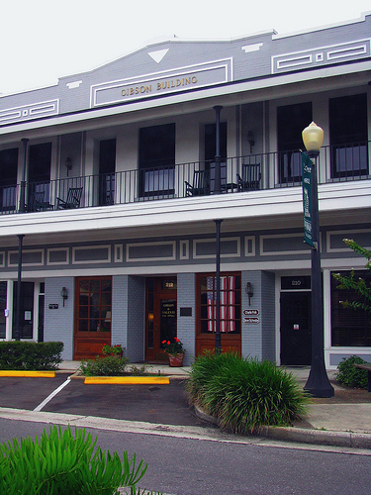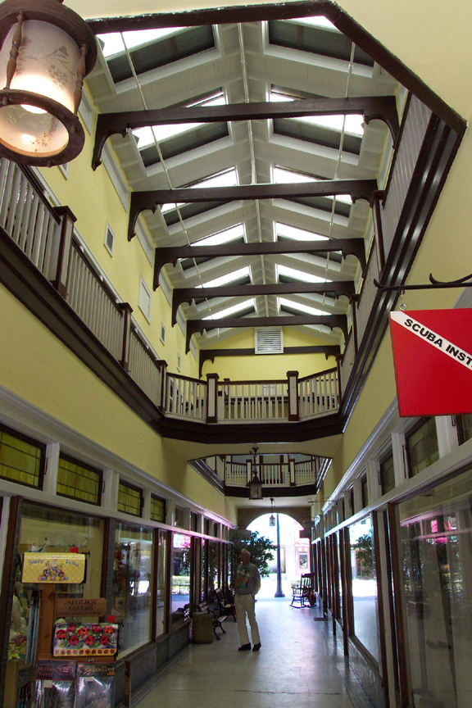
Nearby is the block-long two-story 1919 BULLARD BUILDING that at one time housed a drug store, barber shop, post office, and meat market at once.

OTHER BUILDINGS: Driving along the Scenic Highway (ALT US 27), you will locate other spots but you should go first to the Depot Museum at the 1928 ATLANTIC COAST LINE DEPOT (325 South Scenic Highway), one mile north of downtown. The Depot has a historic guided tour map of Lake Wales and lots of interesting artifacts.
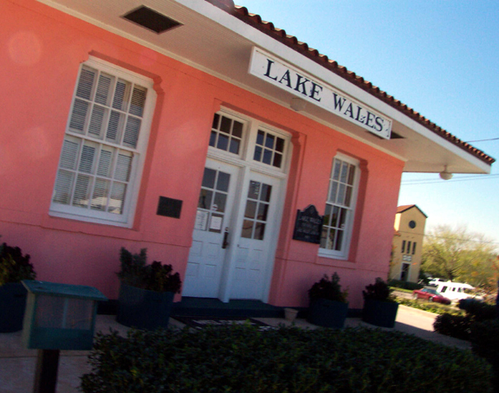
LAKE WALES ART CENTER (1099 Hesperides Road) was the Church of the Holy Spirit, a Spanish Colonial masterpiece with a bell tower. Located on the crest of a hill, the views of the region are beautiful.
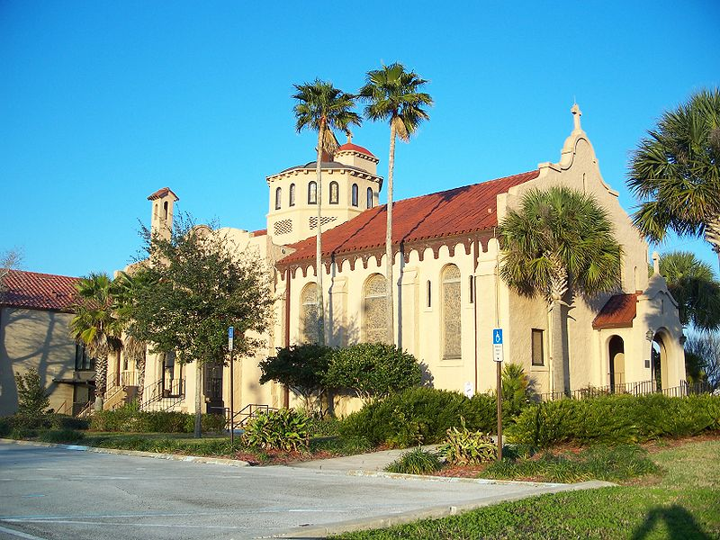
B. K. BULLARD HOUSE (644 South Lake Boulevard) is the 1915 residence of one of the founders of Lake Wales and it’s a classic Colonial Revival.
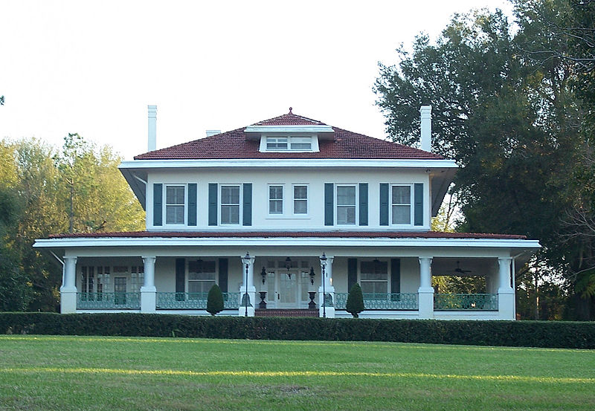
You can stay in the mansion of G. V. TILLMAN (301 East Sessoms Avenue), another 1915 Colonial Revival, this time by the founder of the Lake Wales Land Community. It is a popular bed and breakfast.
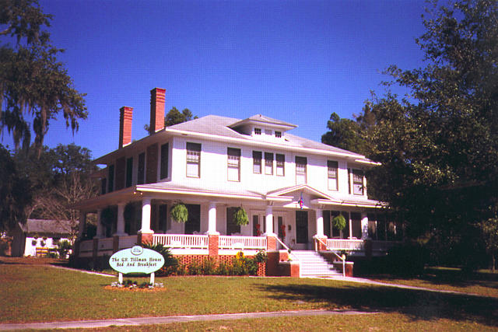
The most spectacular house is two miles northeat on Lake Amoret: the 1923 mansion of realtor I. A. Yarnell known as CASA DE JOSEFINA. The 25-room estate looks more Moorish than Mediterranean and has an exotic parapet.
