BOK TOWER ON IRON MOUNTAIN IN LAKE WALES

Located on the highest spot on the peninsular of Florida (Iron Mountain 287-feet), BOK TOWER was the dream of Ladies Home Journal editor and Pulitzer prize winning author EDWARD BOK. The publisher loved the Central Florida Highlands and wanted to develop a beautiful setting of peace and understanding, where generations of Americans could enjoy the beauty of nature.
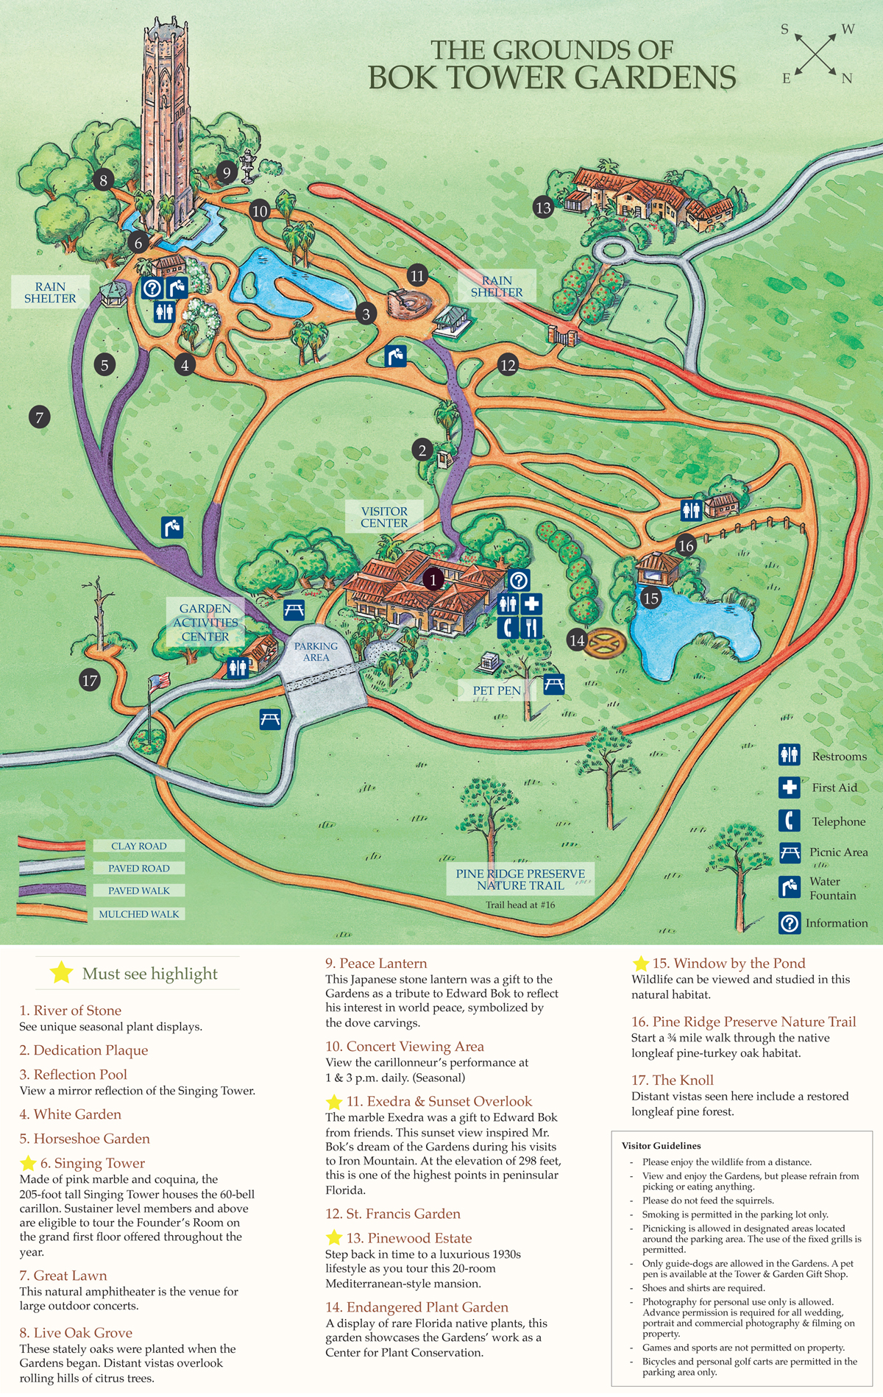
When President Calvin Coolidge dedicated the mountain landscaped by the genius of Frederick Law Olmsted Junior, the focal point of the park was the 205-foot BOK TOWER, a 5,500 ton tower protected by 160 concrete pilings hammered 24 feet into the ground and reinforced by a 150-foot coquina rock base. The entire feast for the eyes is coated with pink Georgia marble.
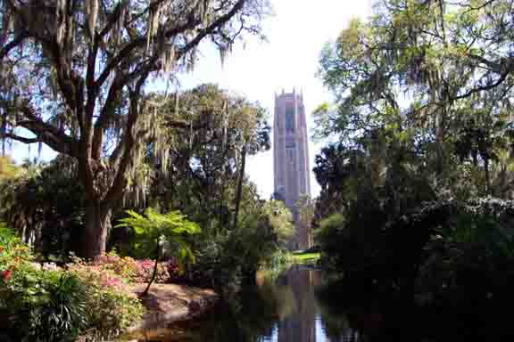
The Tower contains several floors inside and a huge organ that can be heard across the mountain and valley. At the summit is an English water moat and swam-filled lake as well as a large field with park benches.
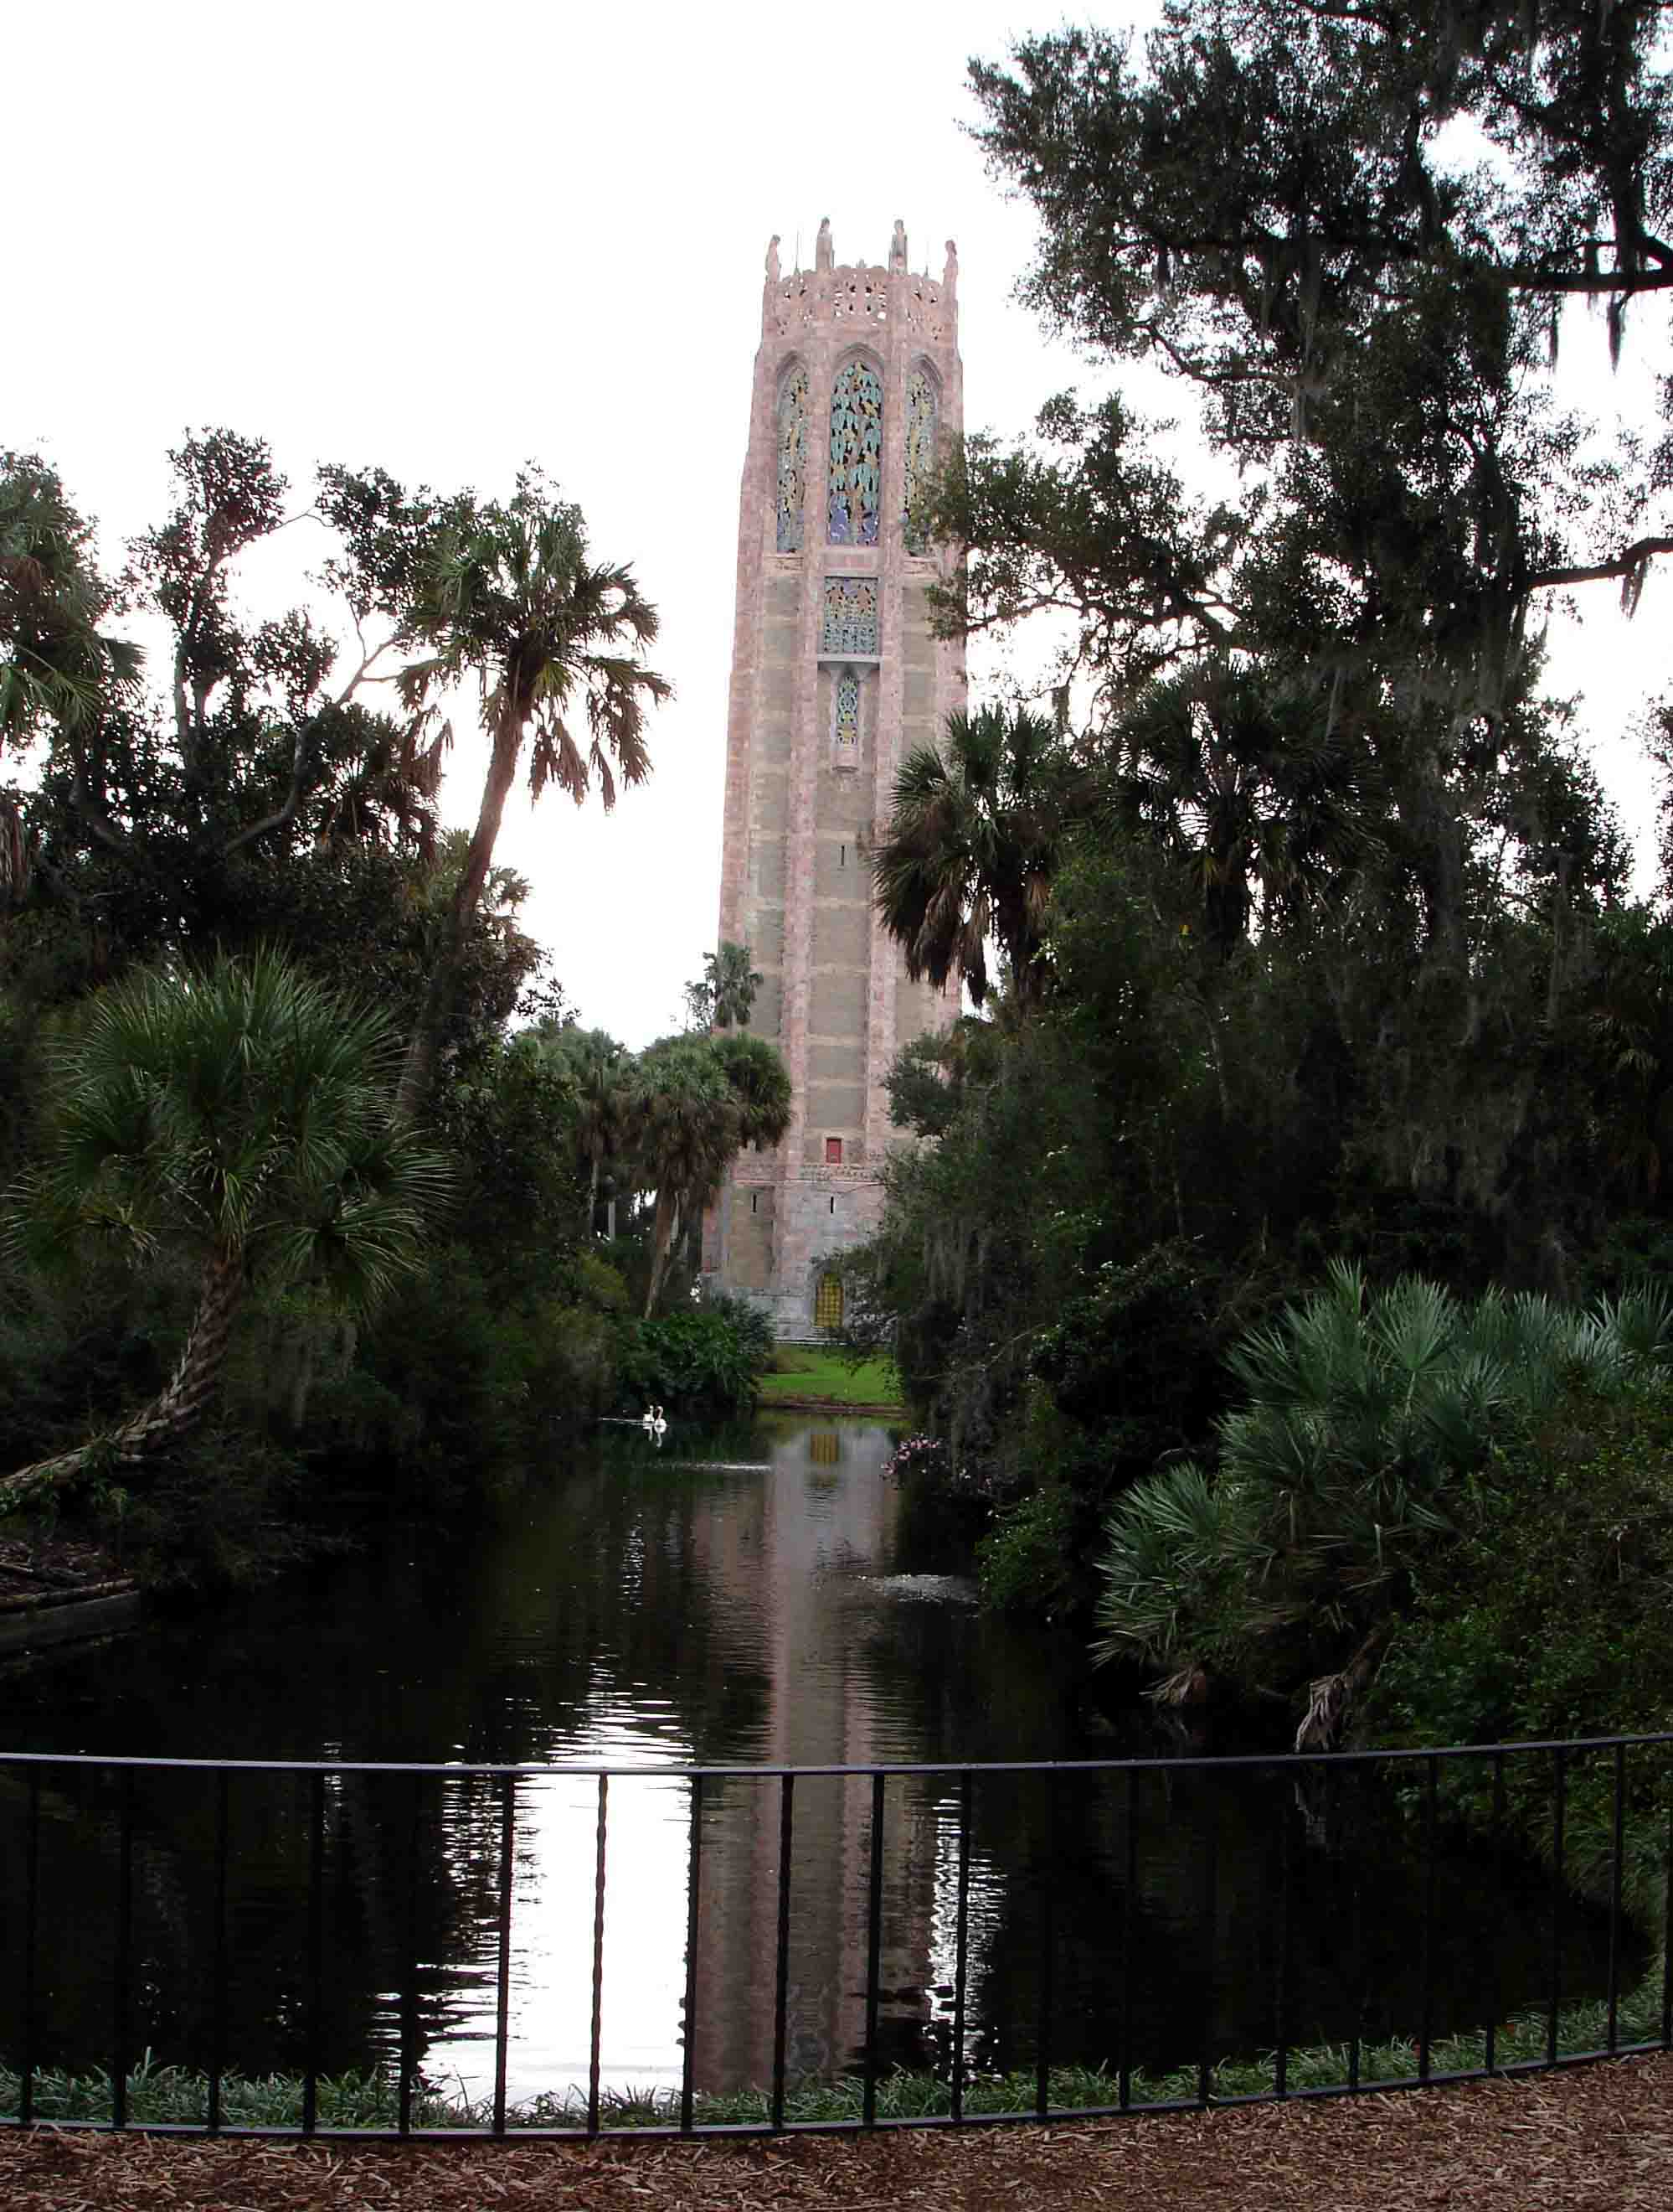
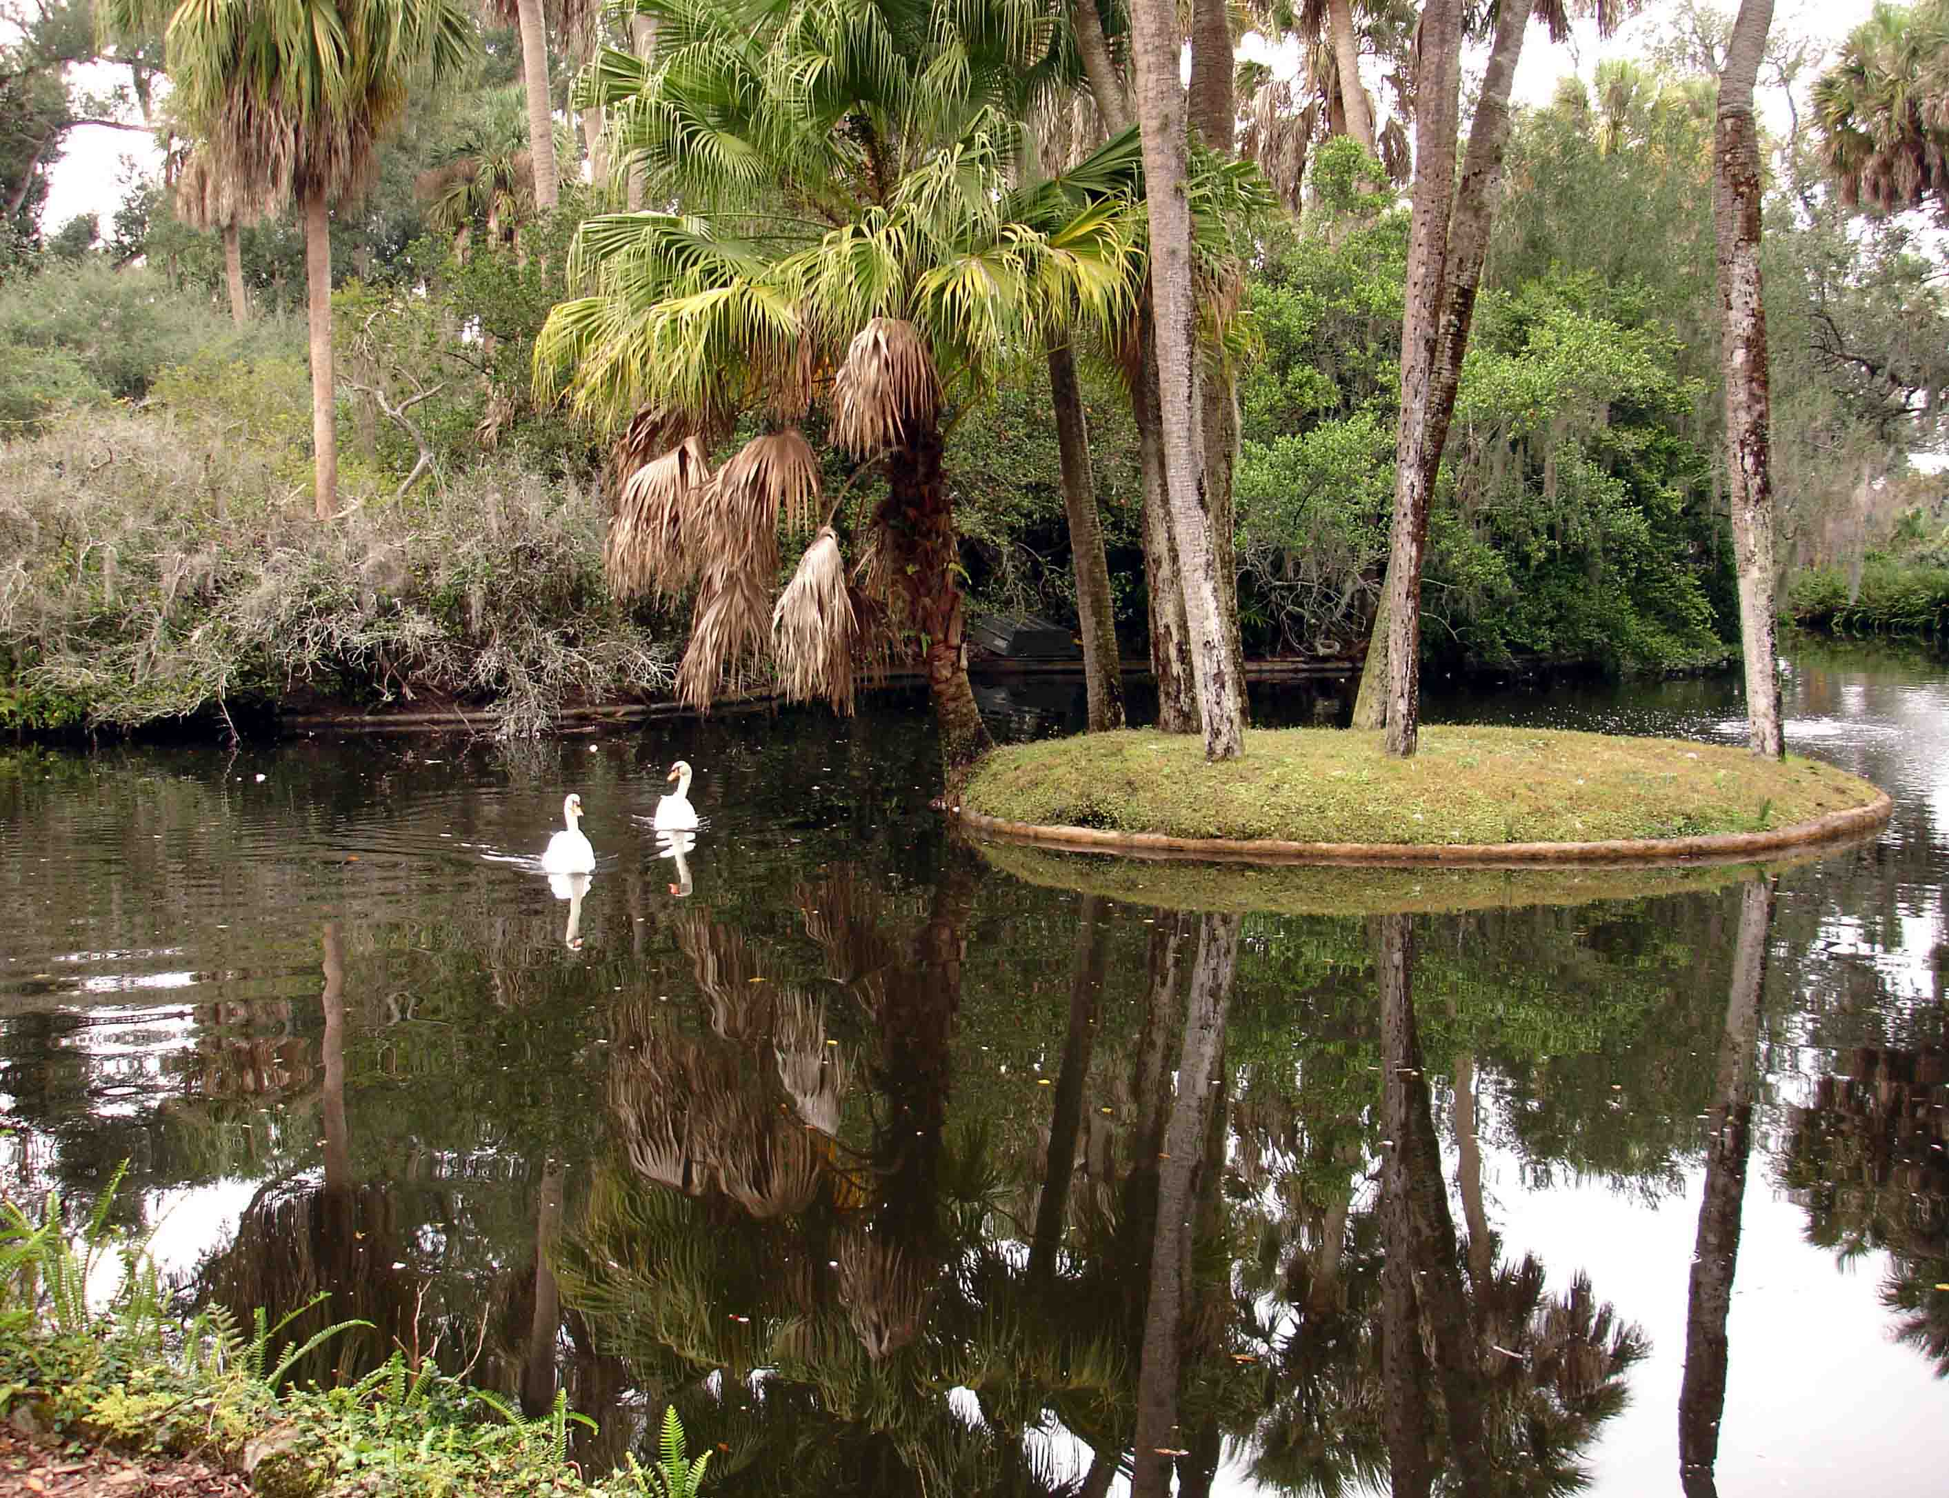
Bok also developed Iron Mountain with its luxurious winter houses for Bok’s Northern friends and others. PINEWOOD ESTATE, the home of Midwestern industrialist C. Austin Buck, is also open to visitors and is at its best when famous designers decorate each room for Christmas.
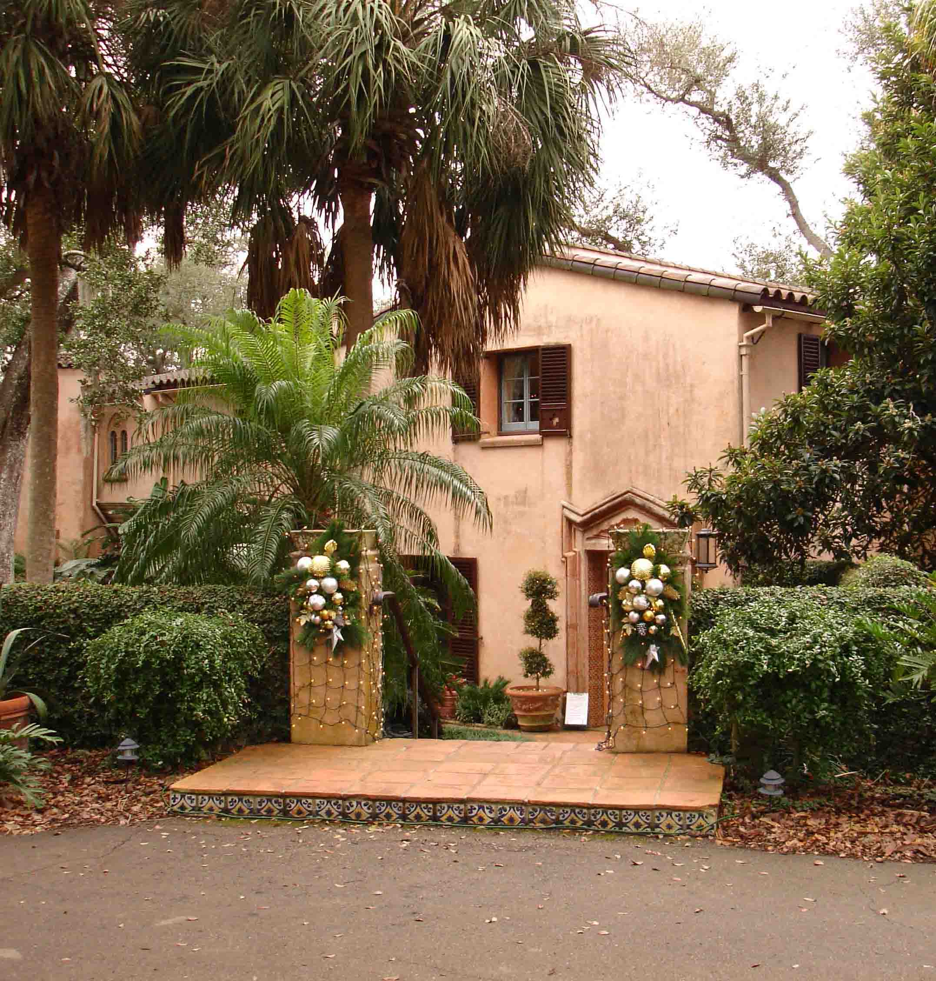
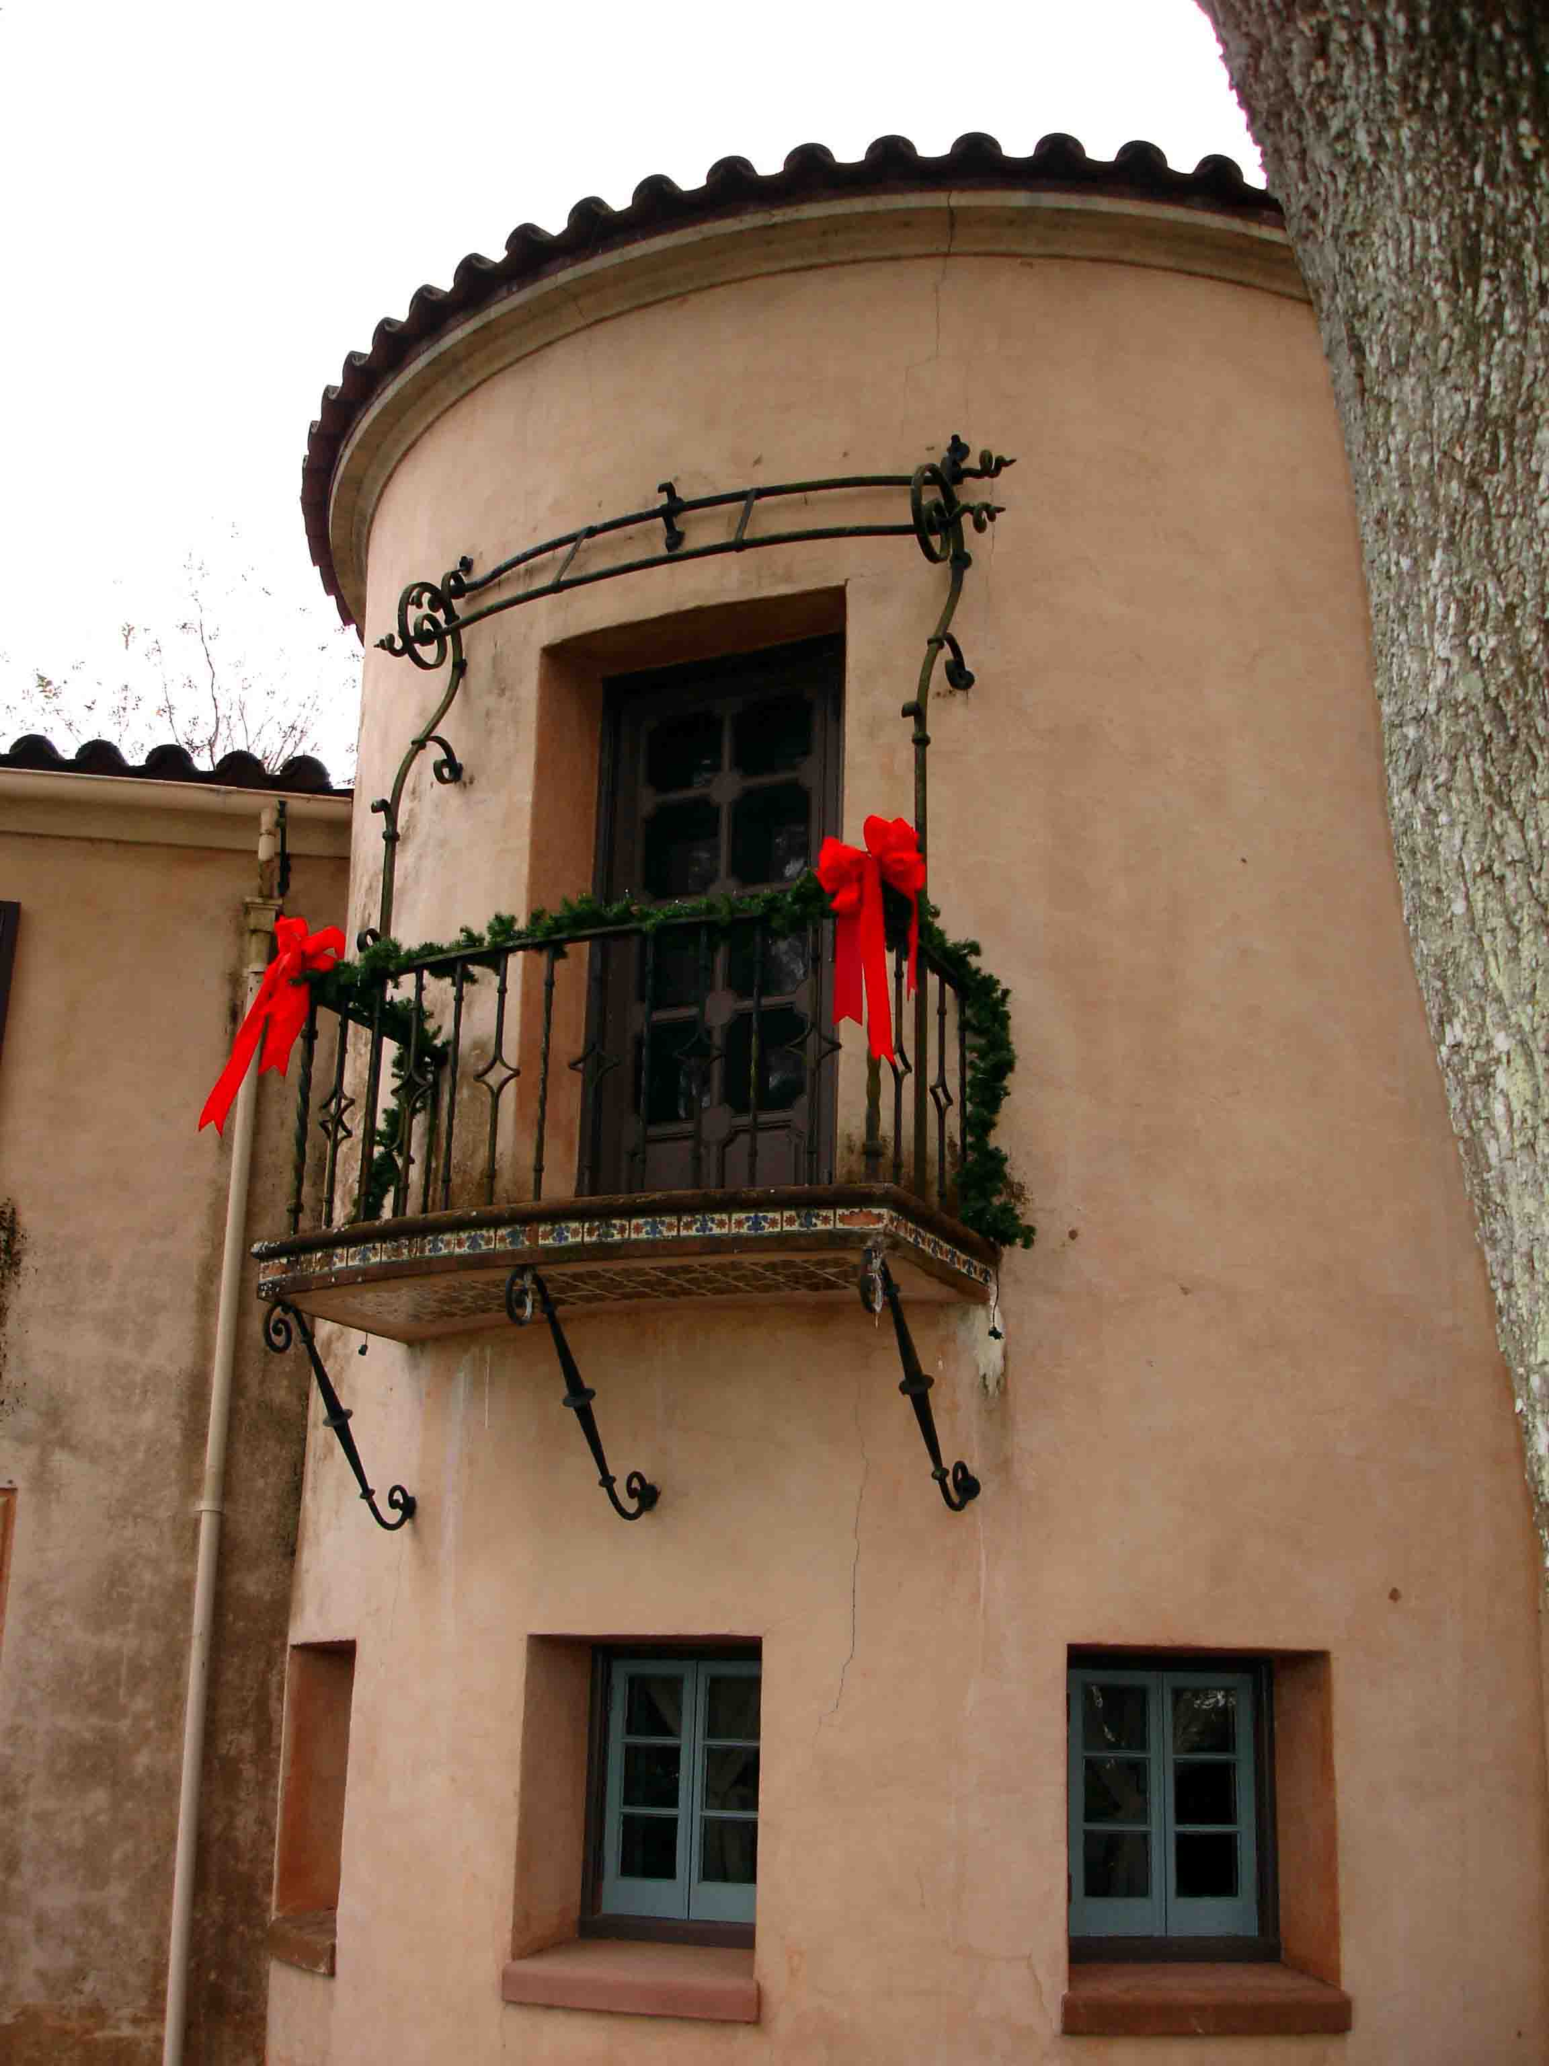

BOK TOWER is one of the great American estate gardens with a location unique in all of Florida.

